Memo No.: COE/ UHS/851 / 2015 Date: 18 /06/2015

THE WEST BENGAL UNIVERSITY OF HEALTH SCIENCES

DD – 36, Sector – I, Salt Lake, Kolkata – 700 064

Website: www.wbuhsexams.in/www.wbuhs.ac.in

( Tel no. 2321-3461 / 2321-6602 )



Information Booklet

Rules for admission to

Diploma in Health Promotion & Education, Diploma in Dietetics and Diploma in Health Statistics Courses in
All India Institute of Hygiene and Public Health

[AIIH & PH], Kolkata

2015
1. Jurisdiction of the University

Admission to the seats in the Diploma in Health Promotion & Education (DHPE), Diploma in Dietetics (Dip. Diet) and Diploma in Health Statistics (D.H.S) Courses in All India Institute of Hygiene and Public Health [AIIH & PH], Kolkata, shall be made on the basis of the inter se merit list and combined merit list of different categories/ castes of candidate on the basis of the results of the Admission Test to be conducted by the West Bengal University of Health Sciences (WBUHS).

2. Eligibility criteria

2.1. Courses are open to citizens of India.

2.2. Diploma in Health Promotion & Education (DHPE):

Medical Graduates (MBBS / BHMS / BAMS / B.U.M.S/ B.D.S) registered with respective Council or Bachelor degree in Arts, Science, Commerce, Education or Nursing from any recognized University.

2.3 Diploma in Dietetics (Dip-Diet):

(i) Medical Graduates (MBBS / BHMS / BAMS/BUMS/B.D.S) registered with respective Council or

(ii) Bachelor University degree with Physiology or Chemistry or Clinical Nutrition with Dietetics as one of the subjects or

(iii) Degree in Nursing [B.Sc.Nursing or B.Sc. (Hons.) Nursing or B.Sc.(Hons.) Cond. Or B.Sc. Cond. Nursing/Post Basic B.Sc Nursing] from a recognised Institution.

2.4 Diploma in Health Statistics (D.H.S):

i) Medical Graduates (MBBS / BHMS / BAMS/BUMS/B.D.S) registered with respective Council
ii) Bachelor Degree with Mathematics/Statistics.
iii) And Science Graduate with Mathematics/ B.Tech and other equivalent.

2.4.1 Candidates who have not studied mathematics in degree course, must have mathematics in class XII and pass class XII examination with mathematics as one of the subjects. Candidates pursuing any other course are also eligible to apply provided the date of completion of the course is or on before 30.07.2015. Otherwise the candidate will have to resign from such course and the resignation will be accepted by the competent authority.

2.5 Multiple Choice Questions to be set from following discipline:

i) Dip-Diet: Basic Nutrition, Physiology, Chemistry, Basic food Science.
ii) DHPE: Basic Public Health Sciences.
iii) DHS- Mathematics XII class standard and basics of statistics.

3. Admission test

Separate Admission tests of DHPE, Dip. Diet and D.H.S will be conducted by the WBUHS to prepare merit list of the candidates seeking admission to different Post-Graduate Diploma Courses conducted by AIIH&PH, Kolkata.

3.1 Applicant will be provisionally allowed to appear in the Admission test provided he/she submits his/her application on-line in the prescribed form for the respective course and hand over the print copy of the application with bank draft of Rs.3000/-.
3.2 The question papers of the Admission tests will be set in English and shall contain 100 single best response type Multiple Choice Questions relevant to the concerned diploma course.
3.3 For each correct response, one (1) mark will be awarded. There will be no negative marks awarded for wrong answers and for questions not attempted. However, multiple answers to a single question will be regarded as wrong answers.
3.4 The duration of each Admission test will be 80 minutes.

4. Method of Submission of application

See Appendix-II of this document

5. Merit List of Candidate

5.1 There is no qualifying marks. Seats will be filled according to merit and reservation policy of Government of India. The rank of the candidate will be determined on the basis of the marks obtained by them in the admission test following descending order of marks.
In the event of more than one candidate securing the same mark, the rank shall be determined according to the following principles:
i. The relative position of such candidate in the merit list will be determined on the basis of the number of wrong answers, i.e., the candidate giving more wrong answers will be placed in lower position in the merit list.
ii. If the rank of the candidate cannot be determined by application of the above principle, the candidate older by age will be in the higher rank than the candidate younger by age.
iii. There shall be combined merit list indicating merit position for UR/SC / ST/OBC/ OBC-A/OBC-B candidates separately. Physically challenged candidates will be placed through horizontal reservation policy. SC/ST/OBC candidate is allowed to compete with UR seat provided such candidate gets marks allotted for UR.

5.2 If seats reserved for SC candidate remain vacant even after following the instruction laid down in the government order and notification, then the same shall be filled by the ST candidate and vice-versa.
5.3 If seats reserved for PC candidate remain vacant even after following the instruction laid down in the government order and notification, then the same shall be filled in from the categories for which it is reserved.
5.4 Seats reserved for OBC/OBC-A/OBC-B if remained unfilled, will be arranged according to government order.

5.5 Calling of names will continue till the seats are filled up.
5.6 OBC categories have to bring current income certificate for claiming a seat in that category.

6. Verification of documents and counselling of selected candidate for admission

Admission to different courses will be made through counselling according to the time schedule.

The provisional merit list and information regarding the venue, date and time of verification of documents and counselling will be available at the WBUHS website. No information will be sent to individual candidate in this regard.
Candidate selected for admission through counselling must join the course on the day of verification of documents on payment of the requisite fees.
A candidate has to appear in person on the date of counselling; otherwise the candidate will be marked absent and his/ her candidature will stand cancelled. However, the candidate or his/her representative appearing for counselling will have to bring the following documents in original:
i) Admit card of West Bengal DHPE/ Dip.Diet/D.H.S Admission Test, 2015

ii) Mark sheets of qualifying examinations (as applicable)

iii) Proof of age eg. Admit Card or passed out Certificate or Certificate of Madhyamik, Secondary or its
equivalent examination.
iv) SC/ST/PC/OBC including OBC-A/OBC-B Certificate. For O.B.C, current income certificate of the family from the competent authority (certificate issuing authority) is required to be produced. Otherwise candidates will not be considered under the OBC/OBC-A/OBC-B category.
v) Documents relating to date of completion or resignation (accepted by the competent authorities) about any other course being pursued by the applicant
vi) Any other relevant documents.

In case a candidate is unable to appear in person on the day of counselling for compelling circumstances, he/she can send his/ her authorized representative with an Undertaking and an Authority Letter (Forms for Undertaking and Authority Letter are available in www.wbuhsexams.in ), along with requisite documents. The allotment made to the authorized representative shall be binding on the candidate.

7. Other Information:

i. Candidate need not submit any supporting documents along with their application form except their proof of identity.

ii. There is no provision for rechecking/ re-evaluation of the answer sheets and no query in this regard will be entertained.

iii. The qualified candidate whose names are published in the Provisional Merit List for counselling for admission to different courses have to submit all the attested copies of supporting documents along with originals for verification during counselling as per the time schedule to be published in due course in University website.
iv. If the qualified candidate fails to produce the supporting documents, he/she will not be considered for counselling under any circumstance.
v. The selected sponsored candidate for DHPE shall have to produce the sponsorship certificate in original at the time of admission for official records.
vi. Please see Appendix –I for Admission Schedule for admission, Appendix-II for Guidelines for Submission of Application, Appendix-III for guidelines for answering through OMR.
vii. Candidate appearing at the test on the basis of his/her own declaration. If it is subsequently found that he is not fit as per required qualification, caste certificate and other norm, his/her candidature will be cancelled. There is no scope of claim that she/he will be allowed to appear at examination.
viii. Getting placement on “Trainee Reserve‟ for government service holder is the responsibility of the candidate. The university should not be requested to take up the issue with concerned government.

8. Stipend

All India Institute of Hygiene and Public Health, 110, C.R Avenue, Kolkata- 700073, teaching institute of the discipline, issued office order vide its file No.S.6-29/2014, dt-25th May, 2015, stating that stipend of Rs. 7500/- per month to non medical post graduate students will be admissible.

. Non –Medical trainees who do not receive full pay and allowances are eligible to get above mentioned stipend . AIIH and PH communicated this input vide its memo no File No 6-29/2014 dated 15 June, 2015

GENERAL RULES AND PROCEDURAL DIRECTIVES

1. Applicant should go through and strictly follow the instructions given in the Information Booklet as published in www.wbuhsexams.in, while applying for Diploma in Health Promotion & Education (DHPE), Diploma in Dietetics (Dip.Diet) Courses and Diploma in Health Statistics (DHS). Application must be complete in all respect.

2. A Print-copy of the application along with a crossed Demand Draft of Rs.3000/-(Three Thousand rupees) in favour of “The West Bengal University of Health Sciences” payable at Kolkata, photographs embossed with current date and photocopy of photo identity card (EPIC/Voter ID/ Driving License/Passport/PAN/Adhar/ any other valid Photo Identity Card) is to submitted either by hand on or before 03.07.2015 and by speed/registered post on or before 06.07.2015 (provided the bank draft is made in favour of The West Bengal University of Health Sciences on or before 02.07.2015) addressed to the Office of “Controller of Examinations” , The West Bengal University of Health Sciences, DD-36, Sector -1, Salt Lake, Kolkata- 700064. In other words the applications must reach office of the WBUHS within the last date as mentioned in the schedule. Candidate is requested to write their name and mobile number on the back of the draft.

3. Submission of incorrect or false statements / documents or suppression of material information in the application form will be considered as sufficient ground for cancellation of the candidature or submission of application form for the admission of the candidate to any course simultaneously whenever detected, i.e. during the process of admission or even at any stage thereafter and incomplete application forms will be summarily rejected.

4. The selection / admission of a candidate shall stand cancelled if he / she is found guilty of copying from any material whatsoever or of taking the help of any electronic media / devices during the examination, or of assisting others or of being assisted by others in any manner whatsoever in writing out the answers during the examination. In this context, decision of the Centre-in-charge and /or the University Observer will be final and binding.
5. Questions will have Multiple Choices that would be answered through OMR.

I) The test will be objective in nature and for each question four suggested responses will be given of which ONLY ONE answer will be chosen as the best response.

II) The Answer Sheet will be machine-scored and therefore requires specific procedure to be followed as given below:
The answers will be marked only by blue/ black ball-pen supplied by the University.

No other pen / pencil are allowed.

III) The method of marking answers is indicated below:

 Each question will be followed by answers marked as (a), (b), (c) or (d). Select the most appropriate answer. Then, using blue/ black ball-pen blacken the circle bearing the correct answer index against the serial number of the question on the answer sheet completely.

Please note that the mark should be dark enough and the circle should be filled in as completely as possible. There is no need to make special efforts to darken any circle artistically.

7. The qualified candidate whose names will be published in the Provisional Merit List will have to submit all the attested copies of supporting documents along with originals at the time of counselling for verification of their eligibility to the course. The Merit list will be notified in the notice-board of the WBUHS and will also be available in the website <www.wbuhsexams.in>. No communication in this regard will be made to the candidate personally.

8 Candidate selected for admission through counselling must obtain the offer letter on the day of counselling on payment of the requisite fees.

9 The candidate should report to the head of the Institution within the date mentioned in the offer letter.

10 IF A CANDIDATE DOES NOT REPORT TO AIIHP&H WITHIN THE STIPULATED DATE HIS / HER ADMISSION TO THE COURSE WILL STAND CANCELLED.

11 No travel allowance is admissible for appearing in the written examination or for attending counselling.

12 No personal communication will be made to the candidate, unless it is considered absolutely necessary by the University authority for incorrect submission of draft , non-submission of photograph and reasons not visualized at the time of uploading the Information Booklet.

13. Admission of candidate belonging to WB Govt. service will be guided in accordance to the relevant Government orders prevailing at the material time.
Appendix-I

Admission schedule for 2015

Forms to be submitted Online in  www.wbuhsexams.in | between 19.06.2015 and 02.07.2015
Submission of print-copy of forms at W.B.  University of Health Sciences (except  Saturday, Sunday and Holidays) | between 19.06.2015 and 03.07.2015  (11.30 a.m. To 4.00 p.m.)
Pay Order/ Demand Draft in favour of The West Bengal University of Health Sciences payable at Kolkata must be purchased on or before 02.07.2015. Print Copies of form along with the Demand Draft/Pay Order will not be received after 03.07.2015.
Registered Post will be received upto 06.07.2015, however the Demand Draft/Pay Order must be purchased on or before 02.07.2015
Admit card will be downloaded from the  website by putting Acknowledgement number/cell number | From 20.07.2015 evening (6 p.m onwards)
Date and time of Admission test | Sunday  26.07.2015  (12.00 noon Onwards)
Declaration of result | On or before 06.08.2015
Date of verification of original documents and  Admission | To be declared later
Report to respective Institution | To be declared later
Course to start from | To be declared later

Controller of Examinations

Date 19.6.2015 The West Bengal University of Health Sciences
Appendix-II

Guidelines for Submission of Application

*1. A candidate seeking admission through Diploma in Health Promotion & Education (DHPE), Diploma in Dietetics (Dip. Diet) and Diploma in Health Statistics Admission Test is required to submit his/her application online by logging in www.wbuhs.ac.in/www.wbuhsexams.in Application submitted by all other means will be summarily rejected.

*2. The candidate will, first of all, visit the university website www.wbuhs.ac.in/www.wbuhsexams.in through internet. He/She is required to go through the relevant ‘Information Booklet’ carefully and acquaint himself/herself with all requirements regarding filling in the application form.

*3. At the Left Hand Side of the homepage under the heading of “ On line Application”, click on either DHPE 2015 or Dip.Diet 2015 or DHS 2015 for which he/she wants to submit the form online.

4. Fill in the ‘Online Application Form’ carefully by selecting appropriate options or by typing in appropriate places. Please do not skip any point. Then click “View’ at the bottom of the page to see what you have entered.

*5. Please check the details of your entry in the next page. If you want to change anything click ‘Back’ at the bottom to go to the previous page to make necessary corrections and then again click ‘View’.

Only after you are fully satisfied, click ‘Submit’ at the bottom to go to the next page. You will not be able to change the data after submitting the form.

After clicking ‘Submit’ two more pages will appear with a „Acknowledgement Number.‟ and the candidate will have to print both the pages as those will have to be submitted to WBUHS. Please keep photocopies of those pages for your record. Submit the form afresh if you do not get any „Acknowledgement Number‟. Application Forms without ‘Acknowledgement Number’ and missing data will not be entertained.

** Once submitted no request for change of any entry will be entertained by the university.

The next page will have to be printed and then „Continue to open the last page‟ at the bottom of the page is to be clicked. The last page also is to be printed. Print-out of these two pages (page 3 and page 4) will have to be submitted to the office of the „Controller of Examinations, West Bengal University of Health Sciences (WBUHS), DD-36, Sector-I, Salt Lake, Kolkata-700064,
i) Pasting one current photographs of the candidate duly snapped after the date of publication of this booklet (one must be attested by a Gazette officer or Principal of the college last attended) at appropriate places in the last page , ( Photograph will contain name and date).
ii) Putting the candidate’s signature at appropriate places in the last page.

iii) The declaration must be signed (which should be fullname) in the same page of the declaration.
iv) Putting left thumb impression in the appropriate place
v) Attaching the bank-draft payable at Kolkata /Pay Order in favour of ‘The West Bengal University of Health Sciences’.

vi) Attestation should be by a Gazette officer with legible seal with designation in the certificate
vii) Attaching photocopy of EPIC/PAN Card.
**1. The instructions given in the print-outs are to be followed scrupulously. The printed hard-copies of last two pages are to be submitted to WBUHS either personally or by registered post/ speed post, so as to reach WBUHS on or before the prescribed last date.

**2. Please keep photocopy of the pages to be submitted for your records.

**3. All forms submitted after the stipulated last date/ all incomplete or invalid forms will be rejected without any further reference to the candidate and the fees submitted, if any, will be forfeited as processing charges.
Appendix-III

INSTRUCTIONS TO CANDIDATE

ANSWERING THROUGH Optical Mark Recognition (OMR) FOR Diploma in Health Promotion & Education (DHPE), Diploma in Dietetics (Dip. Diet) and Diploma in Health Statistics (DHS) Admission Test ,2015

Before writing anything on OMR Sheet, please read very carefully the instruction from beginning to end.

The OMR answer sheet has two parts :
(a) Identification information on the left hand side. (b) Answer sheet on the right hand side.

(A) Identification information (on the left hand side):

Follow the steps carefully :
Step 1 : Check the 6 digit Question Booklet Number.
Step 2 : Enter the 6 digit number in the boxes against the „Question Booklet No‟ in the OMR sheet; one digit in each
box by blackening the corresponding circles below.
Step 3 : Enter the 9digit Roll Number in the boxes provided against „Roll Number‟ in the OMR sheet; one digit in
each box by blackening the corresponding circles below. Step 4 : Put your full signature in the box provided.

(B) Answer sheet (on the right hand side): Please be careful while filling up OMR Sheet :

Step 1 : Use serial nos. 1 to 100 in the right hand side of the OMR Sheet. Please do not Use Serial No. 101 to 200 in that event your OMR Sheet may not be scanned by the Computer.
Step 2 : Check the „Question Booklet Series‟ on your Question Booklet It may be any of the alphabets – A/B/C./D/E
Step 3 : Enter the alphabet in the corresponding box against „Question Booklet Series‟ in the OMR Sheet (on the right
hand side)
Step 4 : Blacken the corresponding round containing the same alphabet adjacent to the box.
Step 5 : Against each question serial number there are four rounds containing alphabets a/b/c/d. Answer by blackening the rounds containing the alphabet corresponding to the answer of your choice. Blacken the round completely only by
the blue or black ball point pen supplied by the University.

Details of marking on OMR Sheet
(i) the OMR Sheet will be machine scanned.
• Do not put any pen/pencil/other mark anywhere except in places as detailed above.
• Do not tamper with the ‘Bar Code’ on the OMR Sheet.
• Do not fold the OMR Sheet.

The method of marking answers is indicated below and on the next page.

a b c d

Select the most appropriate answer

P.T.O
Then using the blue or black ball point Pen supplied by the University, blacken the round bearing the correct answer index against the serial number of the question on the answer sheet (OMR Sheet). For example, if the most appropriate answer to question 2 is (c), it should be marked as follows :

Question 2 a b d

ii Please note : You SHOULD NOT USE any type of pencils or any other ball point pen other the one ball point pen supplied by the University.

iii Some Wrong Methods of Marking Answers :

(Use of Tick Mark) (Use of Cross Mark)
x
√

( Half Filled Round ) ( Use of dot)


(1) You need not make special efforts to darken any round artistically.

(C) The following instructions should carefully be noted by each candidate :

(1) On receipt of Question Booklet the candidate should verify the Question Booklet Series and Roll Number as pasted on the envelope containing the question booklet.
(2) Left thumb impression should be given in the Attendance Sheet in the box provided.
(3) Please ensure that your Name, Roll Number and Signature are put in the boxes provided in the cover page of the Question Booklet.
(4) Please ensure that the Invigilator/Hall-in-Charge puts his/her signature in your Question Booklet and your OMR Sheets in the boxes provided.
(5) After completion of examination the candidate should return the question booklet duly inserted in the envelop and the OMR Sheet separately to the Invigilator/Hall-in-Charge.

(D) Other Important Issues :
I. Please go through the instructions given with the Admit Card
II. For every correct answer (best response) one mark will be awarded. There will be no deduction for wrong answers as well as for non attempted questions.

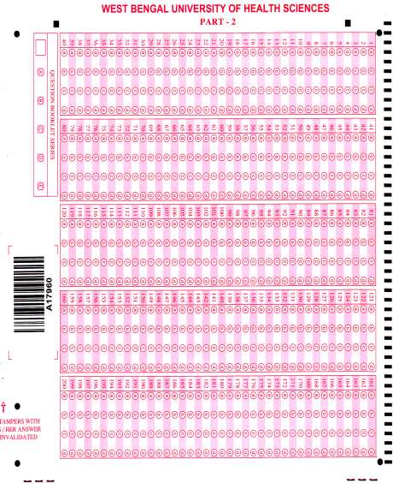
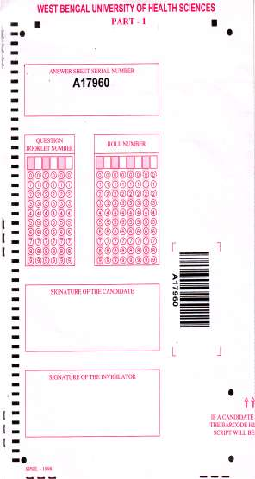

12
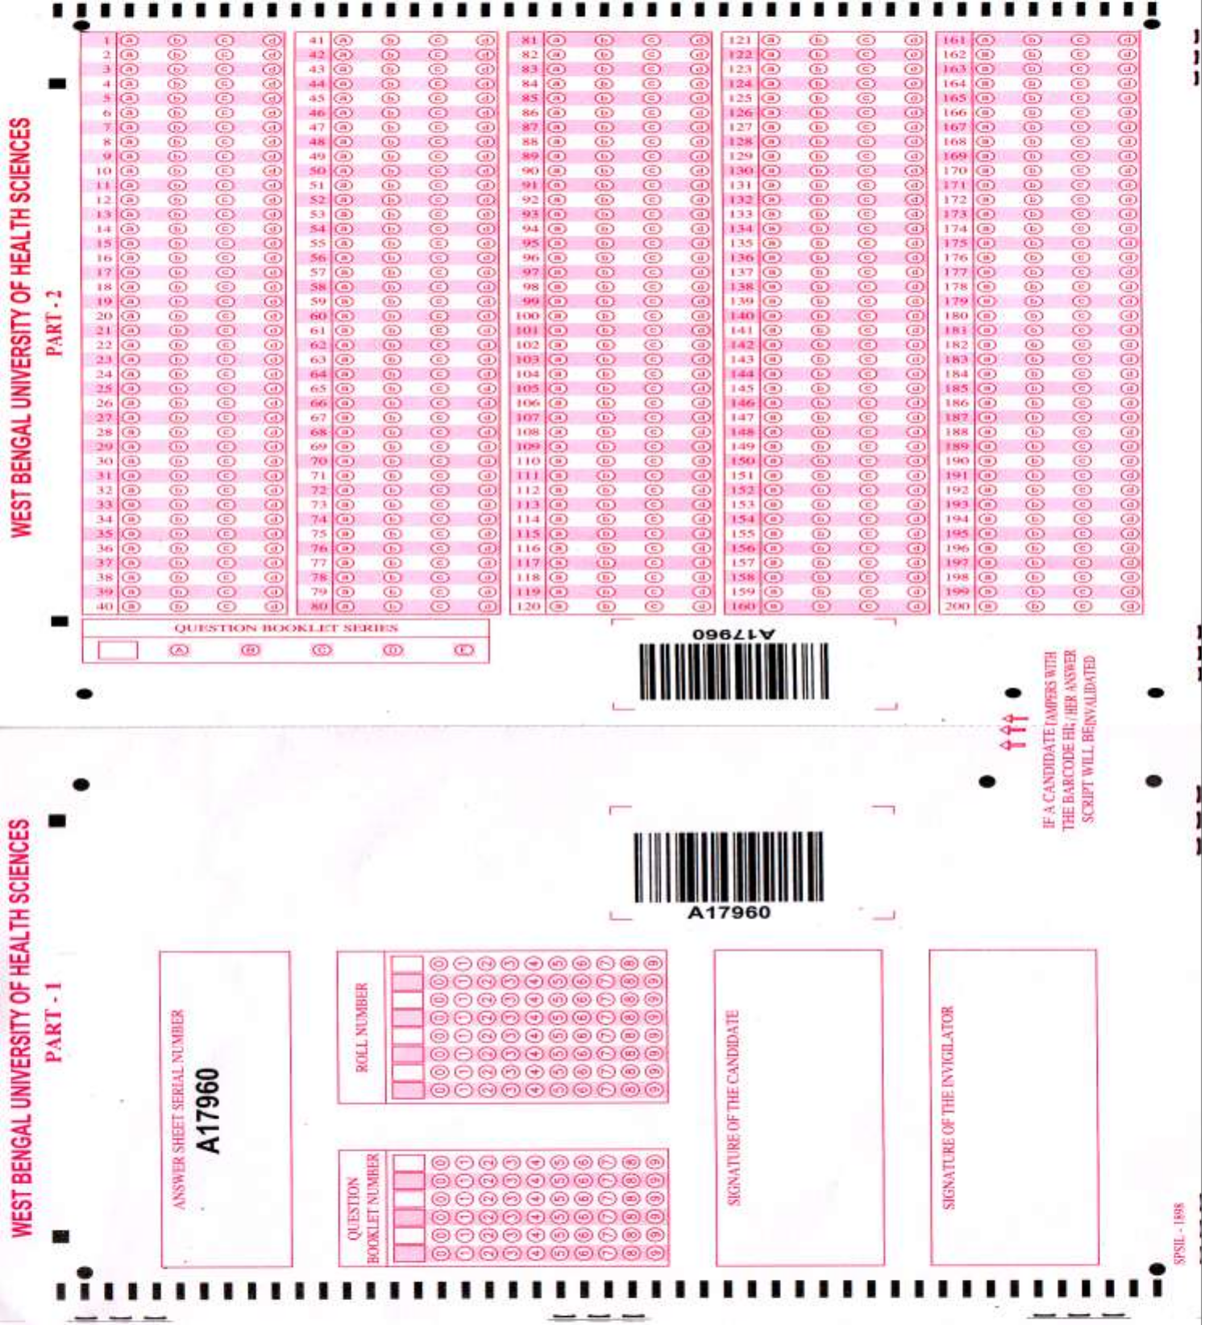

13

