Memo No-COE/UHS/394 /2014 Date: 22.04.2014

THE WEST BENGAL UNIVERSITY OF

HEALTH SCIENCES

DD – 36, Sector – I, Salt Lake, Kolkata – 700 064

Website: www.wbuhs.ac.in /www.wbuhsexams.in


West Bengal Post Doctoral Medical Admission Test, 2014

Information Booklet

Regulations for admission to Post Doctoral Medical Degree courses

2014

- Jurisdiction of the University

  - Admission to different Post Doctoral Medical Courses in institutions affiliated to “The West Bengal University of Health Sciences” shall be made on the basis of inter -se merit list of candidates appearing in the West Bengal Post Doctoral Medical Admission Test-2014 (WBPDMAT-2014) to be conducted by the West Bengal University of Health Sciences (WBUHS) separately for different disciplines of DM and M.Ch. courses as detailed in paragraph 2.6 below.

- Eligibility criteria for D.M. and M.Ch. courses

  - Citizens of India who have obtained the requisite Post Graduate Medical degree (MD/ MS from colleges affiliated by the Medical Council of India and DNB in broad disciplines preferably from teaching institute recognized by National Board of Examinations.)

Applicant is eligible to apply for one course only.

- Application for admission to the Post Doctoral Medical Degree Courses will not be accepted unless the candidates have got themselves registered either with a State Medical Council or with the Medical Council of India.

2.3 A candidate who is likely to obtain the requisite Post Graduate Medical degree qualification by 30 June 2014 may appear at WBPDMAT-2014, but he/she will not be eligible for admission unless he/she produces the proof of passing the said examination from a MCI-recognized institution / DNB recognized institution during interview to be conducted by the University (Date, time and venue of which will be notified in the University Website).
2.4 Candidates other than in -service candidates of Government of West Bengal , if selected have to sign a bond for rendering service for one year after completion of course and training as notified by Government of West Bengal vide its memo no. HF/O/MERT/ 912/MEMISC-78-13 dated 31.7.13. Copy of such notification is annexed with this booklet.

2.5 In-service candidate working under the Health & Family Welfare Department, Government of West Bengal is eligible to apply for admission to the 40% of seats reserved for Government sponsored candidates.

2.5.1 Such candidates working under Health and Family Welfare Department, Government of West Bengal are required to consult with relevant Trainee Reserve Rules 2008 and current notification issued by Government of West Bengal from time to time regarding eligibility and other conditions for availing Government sponsored seats before applying for such seats.
Placement on “Trainee Reserve” is the exclusive prerogative of State Government.

2.5.2 Once option exercised for the seats reserved for government sponsored seats by a candidate , it is final. In service candidates cannot declare himself/herself subsequently as “Open” category candidates during the process of selection. If any seat is not filled by the “ In-service category”, it will be filled by “ Open” category and vice-versa.

Such candidates are required to be cautious and particular in providing information relating to his/her opting for seats reserved for in-service doctors. Leaving the allotted seat after counselling which culminates losing of opportunity of other candidate next to him/her in the merit list will attract the provision of penalty.

However, reservation of in-service doctors will not be barred to any one of such category in getting a seat if s/he is placed at a higher position in the merit list.
As for example, if there are 5 seats in a discipline, 2 seats are reserved for in service doctors and 3 seats are unreserved, an in-service doctor being in third position in its category secures the position in the merit higher than third one of unreserved category, the seat will go in favour of in service doctor. The decision on T.R. and other service related issues will lie with the govt.

2.5.3 Age of in-service candidates will be guided by T.R. Rules 2008 i.e. upper limit is 50 years as on 31.3.2014

  - Candidate who has been pursuing any course, including Post Graduate Medical degree courses as mentioned in 2.3 above, is eligible for admission only if he/she completes the course within 30.06.2014. A certificate in this regard from the appropriate authority has to be produced at the time of counseling. Otherwise, he/she has to submit resignation letter duly accepted by the appropriate authority at the time of counseling.

  - Eligibility qualifications:
Sl. No. | D.M. Courses | Eligibility qualification
1. | Cardiology | MD /DNB(General Medicine)
1. | Cardiology | MD/DNB (Paediatric Medicine)
2 | Clinical Hematology | MD/DNB (General
 |  | Medicine)
 |  | MD /DNB(Pathology)
MD/DNB (Biochemistry)
MD/DNB (Paediatric Medicine)
3 | Clinical Pharmacology | MD/DNB(Pharmacology)
4 | Endocrinology | MD /DNB(General Medicine)
 |  | MD/DNB (Paediatric Medicine)
5 | Medical Gastroenterology | MD /DNB(General
 |  | Medicine)
 |  | MD/DNB (Paediatric Medicine)
6 | Nephrology | MD /DNB(General
 |  | Medicine)
 |  | MD/DNB (Paediatric Medicine)
7 | Neurology | MD/DNB (General
 |  | Medicine)
 |  | MD/DNB (Paediatric Medicine)
8 | Neonatology | MD/DNB Paediatric Medicine
9 | Cardiac Anaesthesiology | MD/DNB Anaesthesiology
10 | Hepatology | MD/DNB (General Medicine & Paediatric Medicine)
11 | Rheumatology | MD/DNB (General Medicine & Paediatric Medicine)
Sl. No. | M.Ch. courses | Eligibility Qualification
1. | Cardiovascular & Thoracic Surgery | MS/DNB (General Surgery)
2 | Urology | MS/DNB (General Surgery)
3 | Neuro-Surgery | MS/DNB (General Surgery)
4 | Paediatric Surgery | MS/DNB (General Surgery)
5 | Plastic & Reconstructive Surgery | MS/DNB (General Surgery)

Note: In case any new course(s) is permitted by Ministry of Family and Welfare Govt. of India before last date of application, such course(s) shall be added to the list above and requisite eligibility qualification as prescribed by the MCI will be applicable.

3. Schedule and Method of Submission of application.

See “Appendix-I” and “Appendix-III “of this document respectively.
4. Selection process

- The selection of candidates for admission to D.M. / M.Ch. Courses will be done on the basis of the marks obtained in the WBPDMAT-2014 (written and interview). Absence in interview will disqualify a place in the merit list.

- Applicants will be provisionally allowed to appear in the WBPDMAT-2014 (written test) provided he/she has submitted application in the prescribed form strictly following direction in Appendix-1 within the last date and has fulfilled the eligibility criteria outlined above.

- The question papers for the Admission tests shall be set in English

- The question paper for the written test for D.M. / M. Ch. (3 years) Course shall be of two sets. The first set will contain 30 single best response type Multiple Choice Questions on the particular subject opted for by the candidate. Subject-specific set will contain questions from associated discipline related to the requisite eligibility qualifications as mentioned in paragraph 2.6 above.
The second set will contain 50 single best response type Multiple Choice Questions on either General Medicine including related basic sciences (for D.M.) or General Surgery including related basic sciences (for M.Ch.).

The candidature of each candidate will be limited to his/her preferred choice of course/subject.
The total time allowed for written test is 70 minutes for two sets.

- Total marks for the Written Test will be of 320.marks. A candidate will be awarded four (4) marks for every correct answer. More than one response to any question will be regarded as incorrect answer.
4.6 There is no negative marking for incorrect answer.

  - A provisional eligibility list to appear for the interview will be published in the University website on the basis of marks obtained in the written test as specified below:

4.8.1 On the basis of marks obtained in the written test consisting of 80 questions, i.e., marks
obtained in 30 questions of the subject specific set opted for + marks obtained in 50 questions of the common set (Basic Sciences). Qualifying minimum marks for empanelment for interview will be 160 marks (50%).
4.8.2 Among the empanelled candidates based on merit list five times of the available seats in both the category will be called for interview.

4.8.3 The qualified candidates in the written test will have to appear in an interview for 80 marks
on the discipline concerned on a date to be declared by WBUHS in its website. No T.A/ D.A is admissible for appearing at the written test and interview. Absence in interview will disqualify a candidate even s/he gets eligible marks in the written test.

4.9 Qualifying marks for empanelment in the final merit list will be a minimum of 200 marks (50%), including 40 marks (50%) in the interview.

- Merit Position of Candidates Qualifying in the WBPDMAT-2014:

The individual merit position will be published on the basis of total marks obtained in the written test and interview taken together.

- The inter-se rank of a candidate qualifying in the WBPDMAT-2014 will be determined

on the basis of the marks obtained by him/her. The roll numbers of the qualified candidates will be arranged in the merit list in order of decreasing marks.

- There shall be a separate panel indicating the merit positions for the applicants who applied for the seats reserved for the government sponsored candidates .

    - In the event of more than one candidate securing the same marks in the WBPDMAT-2014 (written and interview), the rank shall be determined according to the following principles: the relative position of such candidates in the merit list will be determined on the basis of the marks obtained in the written test of 320 marks; candidate obtaining higher marks in the written test will be placed in the higher rank.
    - The relative position of candidates securing same marks in the order of merit will be determined on the basis of the number of incorrect answers, i.e., the candidate with lesser number of incorrect answers will be placed in higher position in merit.

    - If the ranks of the candidates cannot be determined by application of the above principles, the candidate older by age will be in the higher rank than the candidate younger by age.

- Interview and counseling for selection of candidates for admission

  - The provisional panel of names of candidates qualified in the written test as well as the date, time and venue of interview will be available at the www.wbuhsexams.in (This website has direct link with main University Website: www.wbuhs.ac.in ). No information will be sent to individual candidate in this regard.

  - Candidates selected for admission through process of counselling must get themselves admitted by the specified date mentioned in the offer letter.

  - The candidate appearing at interview and subsequent counseling will have to bring the following documents in original along with attested copies of all relevant documents:

(i) WBPDMAT-2014 Admit Card

(ii) MD/MS/DNB certificate/ Provisional passing certificate.

(iii) Registration Certificate issued by MCI/ State Medical Council (iv) School leaving certificate as proof of age

(v) Eligibilty certificate from Health and Family Welfare Deoartment , Government of West Bengal for getting sponsorship, if applicable.
(vi)Course completion certificate from appropriate authority as relevant.

    - Election Photo Identity Card (EPIC) /Permanent Account Number (PAN) Card/ Passport. Candidates without original documents shall not be allowed to appear in the interview.
- BOND:

  - Candidate selected for a postdoctoral seat will be required to sign a bond for completion of tenure of the course, failing which he/she will be required to pay penalty for the default (i.e. non completion of the course) as specified in the relevant Government Order.

  - All students will execute and submit the bond as mentioned at 7.1 in the office of the respective Head of the Institute by 31.8.2014.

  - If a candidate resigns the selection/residency by 31.8.2014, he/she will have to pay the penalty as per 7.1.
7.4 Selected candidate other than in service candidates of Government of West Bengal have to sign a bond for rendering service for one year after completion of course and training as notified by Government of West Bengal vide its memo no. HF/O/MERT/ 912/MEMISC-78-13 dated 31.7.13. Copy of such notification is annexed with this booklet. (Appendix no.- VII)

- Process for filling vacant seats

After first round of counseling and admission, vacant seats, if any, will be filled in from the final merit list of the qualified candidates. Candidates who have attended the first round of counseling will only be considered for any subsequent round of admission. The University authority may conduct counseling process to fill vacant seats as deemed fit till 15.9.2014.

9. Other information

9.1 Candidate will produce the original and submit photocopy of EPIC/PAN Card /Passport
with the application form. Other testimonials are not required with application form.
9.2 The allotment of centre will be done by the WBUHS and will be final and binding. The
centre once allotted shall not be changed.
9.3 There is no provision for rechecking/ re-evaluation of the answer sheets and no query in this
regard will be entertained.
9.4 Candidates are required to visit the university website regularly for latest
information.
9.5 Candidate will have to submit digitized signature and photograph
( Current photograph snapped after publication of booklet) at the time of filling application which are to be used for future tasks like generation
of Admit card, attendance sheet , offer letter of admission etc.
9.6 Mere getting a place in the merit list will not qualify a candidate if otherwise s/he is ineligible.
9.7 In case of doubt intending candidates may send mail in the address wbuhs_ctlr@rediffmail.com or vcwbunivhealthsciences@gmail.com

APPENDIX-I

Schedule for WBPDMAT-2014

Forms to be submitted Online in | 22.04.2014 – 06.05.2014 ( 6 p.m.)
www.wbuhsexams.in
Submission of print-copy of forms at W.B. | From 22.04.2014 – 06.05.2014
University of Health Sciences (except Saturdays,
Sundays and Holidays) personally | (11.30 a.m. to 4.00 p.m.)
Print-copies will not be received in the office of the WBUHS in person after 07.05.2014 However
print-copies sent by Speed Post will be received up to 09.05.2014
provided the Bankers’ cheque/ Demand Draft” is purchased on or before 06.05.2014
Admit Card will be downloaded by the candidate | 21.05.2014 , 6:00 pm
from the University website
Date and time of Admission Test (Written test) | 25.05.2014  12:00 noon- 1:10pm
Declaration of results of written test & publication of | On or before 05.06.2014
eligibility list for Interview
Date of Interview and submission of attested copies | Between 15.06.2014 and 30.06.2014
and verification of original documents
Declaration of final result (final ranking) | On or before 30.06.2014
Date of Counseling & Admission | To be notified in the university website in due course.
Course to start from | 01.08.2014

APPENDIX-II
GENERAL RULES AND PROCEDURAL DIRECTIVES

- Applicants should go through and strictly follow the instructions given in the Information Booklet as published in www.wbuhs.ac.in / www.wbuhsexams.in in April 2014 and refer to schedule while applying for different Post Doctoral courses. Application must be complete in all respect.

- The print-copy of the application along with a crossed Demand Draft / Pay Order of Rs. 5000/-/ in favour of The West Bengal University of Health Sciences payable at Kolkata is to be submitted either by hand or by Speed / Registered post to the office of the “Controller of

Examinations, The West Bengal University of Health Sciences, DD-36, Sector-I, Salt

Lake, Kolkata-700064”, so that it reaches the office of the WBUHS within 09.05.2014. ( Condition applies as stated in Annexure-I)

Candidates are requested to write name, telephone no., mobile no. and “Acknowledgement No.”, mentioned on the print-out of the form on the back of the bank draft. The candidate will

mention name of the examination (WBPDMAT-2014) on the back of the envelop.

- No other document except a photocopy of EPIC/PAN card/ Passport and bank draft is to be submitted with application form.

- Submission of incorrect or false statements / documents or suppression of material information in the application form will be considered as sufficient ground for cancellation of the candidature or the admission of the candidates to a Post Doctoral medical course whenever detected, i.e. during the process of admission or even at any stage during pursuing the course and thereafter.

- The selection / admission of a candidate shall stand cancelled if he / she is found guilty of copying from any material whatsoever or of taking the help of any electronic media / devices during the examination, or of assisting others or of being assisted by others in any manner whatsoever in writing out the answers during the examination. In this context, decision of the Centre-in-charge will be final and binding.

- Candidate can download his/her admit card from the University website on and from 21.5.2014 onwards.

- The qualified candidates whose names will be published in the Provisional Merit List will have to submit all the attested copies of supporting documents along with originals for verification of their eligibility to the course during interview as mentioned in paragraph 6.3

- The date, time and venue of interview will be notified in the notice-board of the WBUHS and will also be available in the website <www.wbuhs.ac.in or www.wbuhsexams.in>. No communication in this regard will be made to the candidates personally.

- Candidates selected for admission after interview must obtain the offer letter on the last day of counseling for the concerned subject.

- The candidate, after admission, should report to the head of the institution within 23.07.2014. Failure to report will render the seat vacant.

- If a candidate does not report to the allotted institution, his / her admission to the course will be cancelled.

- No travel allowance is admissible for appearing in the admission, examination or for attending interview.

- No personal communication will be made to the candidates, unless it is considered absolutely necessary by the University authority.

Date:21 April, 2014 Controller of Examinations, The WBUHS
 |  | Appendix-III
 |  | Guidelines for Submission of Application
 | - A candidate seeking admission through WBPDMAT is required to submit his/ her application
 | online by logging in www.wbuhs.ac.in or www.wbuhsexams.in
 | Application submitted by all other means will be summarily rejected.
. | - The candidate will, first of all, visit the university website www.wbuhs.ac.in/ www.wbuhsexams.in through internet.
 | S/he is required to go through the relevant “Information Booklet” carefully and acquaint herself
 | /himself with all requirements regarding filling in the application form.
 | - At the Right Hand Side of the homepage under the heading of “Examination”, click on West Bengal Post Doctoral Medical Admission Test ( WBPDMAT) 2014 for D.M. or M. Ch courses for which he/ she wants to submit the form online.
 | - Fill in the “Online Application Form” carefully by selecting appropriate options or by typing in appropriate places. Please do not skip any point. Attach your scanned recent passport size photograph, signature and left thumb impression in appropriate places. Then click “submit” at the bottom of the page to see what you have entered.
 | - Please check the details of your entry in the next page. If you want to change anything, go back to first page and fill again. If necessity arises for change in the First Page , click “ Reset” at the bottom and continue , then click “Submit” at the bottom to go to the next page. After clicking “Submit” two more pages will appear with an “Acknowledgement number ” and the candidate will have to print both the pages as those will have to be submitted to the WBUHS. Please keep photocopies of those pages for your record. Submit the form afresh if you do not get any “Acknowledgement Number.” Form without Acknowledgement Number and missing data will not be entertained.

Once submitted, no request for change of any entry will be entertained by the University.

Print-out of these two pages will have to be submitted to the office of the “Controller of Examinations, West Bengal University of Health Sciences (WBUHS), DD-36, Sector-I, Salt Lake, Kolkata-700064” after:

- pasting one current photograph at the appropriate place of the candidate duly snapped after the date of publication of this booklet (must be attested by a gazetted officer or Principal of the college last attended. Photograph will contain name and date)

- Putting the candidate‟s signature at appropriate places.

- The declaration must be signed (which should be full name) in the same page of the declaration.

- Attaching the bank-draft / pay order for Rs. 5000/- in favour of “The West Bengal

University of Health Sciences” payable at Kolkata

- Attestation should be by a gazetted officer/ Principal o with legible seal with designation in the certificate.

- Attaching photocopy of EPIC/PAN Card

**1. The instructions given in the print-outs are to be followed scrupulously. The printed hardcopies of last two pages are to be submitted to the WBUHS either personally or by registered

post/ speed post, so as to reach the WBUHS on or before the prescribed last date.

**2. Please keep photocopy of the pages to be submitted.

**3. All forms submitted after the stipulated last date/ all incomplete or invalid forms will be rejected without any further reference to the candidate and the fees submitted, if any, will be forfeited as processing charges.
Appendix-IV
Annexure of Clause 6:
Seat Matrix will be displayed before written examinations.

Note: New course(s), if permitted by the Govt. of India and Letter of Permission

received before last date of application, such course(s) shall be added to the list above. Updated information will be available in University website accordingly.
Appendix –V

INSTRUCTIONS TO CANDIDATES ANSWERING THROUGH

Optical Mark Recognition

(OMR) FOR WEST BENGAL POST DOCTORAL MEDICAL ADMISSION TEST-2014

Before writing anything on OMR Sheet, please read very carefully the instruction from beginning to end. For two sets of questions booklets, follow similar steps.

The OMR answer sheet has two parts:

- Identification information on the left hand side.

- Answer sheet on the right hand side.

(A) Identification information (on the left hand side):

Follow the steps carefully :

Step 1 : Enter the 9 digit Roll Number in the boxes provided against “Roll Number” in the OMR sheet; one digit in each box by blackening the corresponding circles below.

Step 2 : Put your full signature in the box provided.

For two separate sets of Question booklet and two sets Answer sheet (on the right hand side): Please be careful while filling up OMR Sheet :

For the first set of questions in the first booklet use first part of the right side of the OMR

Step 1 : Use serial nos. 1 to 30 in the right hand side of the OMR Sheet.

Step 2 : Check the “Question Booklet Series” on your Question Booklet It may be any of the alphabets – A/B/C/D/E

Step 3 : Enter the alphabet in the corresponding box against “Question Booklet Series” in the OMR Sheet (on the right hand side)

Step 4 : Blacken the corresponding round containing the same alphabet adjacent to the box.

Step 5 : Against each question serial number there are four rounds containing alphabets A/B/C/D.

Answer by blackening the rounds containing the alphabet corresponding to the answer of your choice either of a/b/c/d in the Question Booklet. Blacken the round completely only by the blue or black ball point pen supplied by the University.

For the second set of questions in the second booklet, use second part of the right side of the OMR
Step 1 : Use serial nos. 1 to 50 in the right hand side of the OMR Sheet.

Step 2 : Check the “Question Booklet Series” on your Question Booklet It may be any of the alphabets – A/B/C/D/E

Step 3 : Enter the alphabet in the corresponding box against “Question Booklet Series” in the OMR Sheet (on the right hand side)

Step 4 : Blacken the corresponding round containing the same alphabet adjacent to the box. Step 5 : Against each question serial number there are four rounds containing alphabets a/b/c/d. Answer by blackening the rounds containing the alphabet corresponding to the answer of your choice.

Blacken the round completely only by the blue or black ball point pen supplied by

the University.

Details of marking on OMR Sheet

- the OMR Sheet will be machine scanned.

  - Do not put any pen/pencil/other mark anywhere except in places as detailed above.

  - Do not tamper with the “Bar Code” on the OMR Sheet.

  - Do not fold the OMR Sheet.

The method of marking answers is indicated below and on the next page.



A B C D

Select the most appropriate answer

Then using the blue or black ball point Pen supplied by the University, blacken the round bearing the correct answer index against the serial number of the question on the answer sheet (OMR Sheet). For example, if the most appropriate answer to question 2 is

(c) it should be marked as follows : Question 2


A B D

ii Please note : You SHOULD NOT USE any type of pencils or any other ball point pen other the one ball point pen supplied by the University.
iii Some Wrong Methods of Marking Answers :

(Use of Tick Mark): (Use of Cross Mark):
X

✓

( Half Filled Round ) : (Use of dot):



(1) You need not make special efforts to darken any round artistically.

- The following instructions should carefully be noted by each candidate :

(1) On receipt of Question Booklets the candidate should verify the Question Booklet Series and Roll Number as pasted on the envelope containing the question booklet.

(2) Left thumb impression should be given in the Attendance Sheet in the box provided.

(3) Please ensure that your Name, Roll Number and Signature are put in the boxes provided in the cover page of the Question Booklet.

(4) Please ensure that the Invigilator/Hall-in-Charge puts his/her signature in your Question Booklet and your OMR Sheets in the boxes provided.

(5) After completion of examination the candidate should return two question booklets duly inserted in the envelop and the OMR Sheet separately to the Invigilator/Hall-in-Charge.

- Other Important Issues :

Please go through the instructions overleaf of

Admit Card
MODEL OMR SHEET
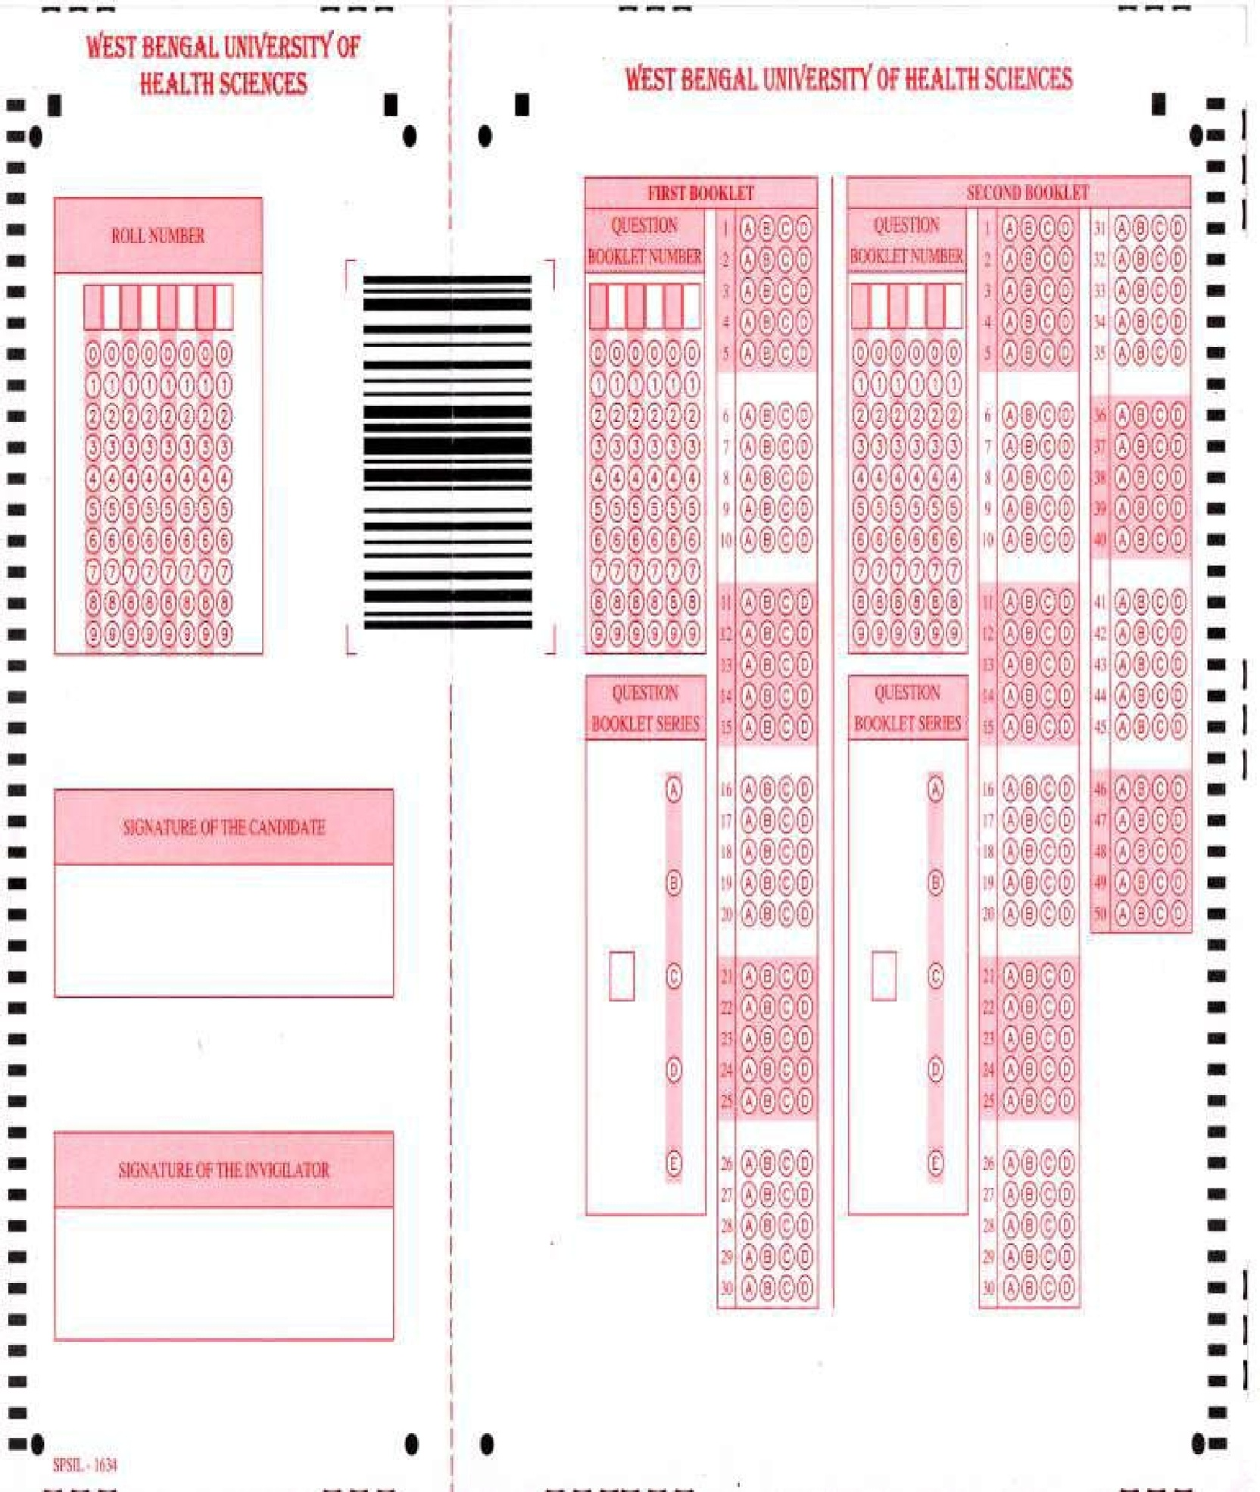
Appendix –VI
Government of West Bengal
Department of Health & Family Welfare,
MERT Branch
“Swasthya Bhawan”, Block-G.N-29
Sector-V, Salt Lake City, Kolkata-700 091.
No.HF/O/MERT/ 1542 /Admn./ME/STM-28-10Dated Kolkata, the 25th October,2010

From : The Special Secretary to the Government of West Bengal.

To : 1) The Director of Medical Education
2) The Director of Health Services, West Bengal.

M E M O R A N D U M

In cancellation and supersession of all previous guidelines / principles regarding admission criteria of Undergraduate, Post Graduate and Post Doctoral students of both stream namely Medical and Dental, the undersigned is directed to convey the approval of this State Government to the following procedures in respect of admission to undergraduate / Post Graduate Degree or diploma / or Post Doctoral courses in the Government Institutions of this State, Istitute of Child Health (ICH), Kolkata and Vivekanada Institute of Medical Sciences (VIMS), Kolkata.

- Admission has to be made on the spot mandatorily during counseling in the Govt. Medical / Dental institute, ICH and VIMS according to merit list of selected students.

- An admitted student will have to deposit the original copy of certificate of qualifying examination, original copy of mark sheet of qualifying examination and original copy of Medical Registration‟ Certificate in case of Post Graduate and Post Doctoral courses. Accordingly a MBBS / BDS student will have to deposit his / her”10+2 Examination‟ certificate and original copy of mark sheet of 10+2 Examination. A “PG degree / diploma student will have to deposit his / her original copy of MBBS / BDS certificate, original copy of mark sheet of final year MBBS / BDS Examination‟ and original copy of”Medical / Dental Registration Certificate. A Post Doctoral student will have to deposit his / her original copy of MD / MS Certificate, original copy of mark sheet of MD/ MS Examination and Medical Registration‟ Certificate.

- All the above documents required to be submitted by a student will have to be physically deposited to the admitting institution within 10 days of spot admission through counseling, failing which admission will be considered deemed to be cancelled and the seat will be offered to other student during re-counseling. On receipt of original documents from an admitted student, the concerned Head of the Institution will issue a certificate to the candidate indicating the details of documents kept under Institutional custody.

- If a candidate desires to attend any recounselling session in this State, he / she shall appear in

recounselling with the certificate issued to him / her by the”Head‟ of admitting institution of the first counseling, showing the details of documents kept under custody of the institution. Subsequently, documents of such a student, in the event of his / her admission to other institution, shall be transferred by the”Head‟ of admitting institution where at the student

was admitted through the first councelling, to the Head of admitting institution on the basis of recounselling within 15 days by special messenger under proper receipt with intimation to the student concerned. On receipt of the said documents, the concerned Head of second institution will issue a certificate to the candidate indicating the details of documents kept under institutional custody.
- If a candidate desires to attend any counselling / recounselling outside this State, the said documents are to be handed over to the candidate under proper receipt subject to the condition that he / she will have to redeposit the said documents at least 3(three) days prior to the date of recounselling in this State failing which the earlier admission granted on the basis of the first counseling will be considered deemed to be cancelled and the seat

will be offered to other student during recounselling.
- Original documents of a student will be handed over to him / her only on

completion of course to which he / she has been admitted. In case of any discontinuation from the course offered or resignation from that course after recounselling of this State, all original documents deposited by the candidate shall be handed over to him only on payment of a penalty charges as stated below:

  - A MBBS / BDS student will be required to pay a penalty charge of Rs.1,00,000/-(Rupees one lakh) only after which his / her original documents deposited will be released to him / her by the concerned institution.

  - A”Post Graduate Diploma‟ student will be required to pay a penalty charge of

Rs.2,00,000/- (Rupees two lakh) only after which his / her original documents deposited will be released to him / her by the concerned institution.

iii) A”Post Graduate Degree/Post Doctoral student will be required to pay a penalty charge of Rs.5,00,000/- (Rupees five lakh) only after which his /her original documents deposited will be released to him / her by the concerned institution.

- In case a resignation is offered by a candidate on the spot during recounselling in this State, he / she shall not be liable to pay any penalty and all original documents deposited in custody of admitting institution on the basis of the first counseling shall be returned to him / her.

- All the above mentioned principles / criteria shall also be applicable to students of All India Quota and all other quotas including SSKM Trustee quota.

- All concerned are being informed.

Special Secretary

No. HF/O/MERT/ 1542/Admn./ME/STM-28-10/1(6)Dated Kolkata, the 25th October,2010

Copy forwarded for information and necessary action to the :
- Principal Accountant General (A&E), West Bengal, Treasury Buildings, Kolkata-1.

- Accountant General (Local Bodies Audit), C.G.O. Complex, 3, M.S.O. Building (5th floor), Block-DF, Salt Lake City, Kolkata-700064.

- Additional Director of Health Services (AA&V), West Bengal.
- Pay & Accounts Officer, Kolkata Pay and Accounts Office, 81/2/2, Phears Lane, Kolkata-700012.

- Treasury Officer, Burdwan/Siliguri/Darjeeling/Bankura/Paschim Midnipur/Malda/Murshidabad/Nadia.
- Finance Department(Group-O)/ (Group-N) of this Government.
Special Secretary

No. HF/O/MERT/ /Admn./ME/STM-28-10/1(9) Dated Kolkata, the

- Vice-Chancellor, West Bengal University of Health Sciences, West Bengal.

- Principal, Medical College, Kol./NRS Medical College, Kol /RG Kar Medical College, Kol/CNMC, Kol./BSMC Bankura/BMC Burdwan/NBMC Darjeeling/MMC, Paschim Midnipur/RADC, Kol./BDC, Burwan/NBDC, Darjeeling/ID&BG Hospital, Kol./Dr. B.C. Roy Memorial Hospital for Children, Kol./CSS, Kol. with request to deploy necessary staff of his / her institution for arranging spot admission of the student allotted to his / her institution on the days of counseling.
- Director, IPGME&R, Kol./BIN, Kol./STM, Kol./RIO, Kol./ICVS, IPGME&R(SSKM), Kol./ICVS (RGKMC), Kol.IHTM, Kol./ICH, Kol./VIMS, Kol./ AIIH&PH, KOl with request to deploy necessary staff of his / her institution for arranging spot admission of the student allotted to his / her institution on the days of councelling.

- The Registrar, WBUHS, Kolkata with a request to publish this memo at a suitable place in the„Information Booklets of Entrance Examination for admission to Medical / Dental PG Degree / Diploma courses and also in the Information Booklet of Entrance Examination for admission to Post Doctoral courses.

5. Dean, Faculty of Medicine, WBUHS/VIMS/AIIH&PH/ICH, Kol.

- P.S. to The Principal Secretary (H&WF), West Bengal.

- Joint Secretary (MERT) of this Department.

- Asst. Secretary (MERT) of this Department.

- OSD (MERT) of this Department.

- P.A. to Special Secretary (MERT) of this Department.

Special Secretary

• | In- service candidate | of Government of West Bengal | is requested to go through
 | Gazette notification no HF/O/MERT/416/HPT/23T -14 -2000 dated 24 April, 2008
 | issued by Department of Health and Family Welfare , Government of west Bengal (
 | MERT BRANCH)

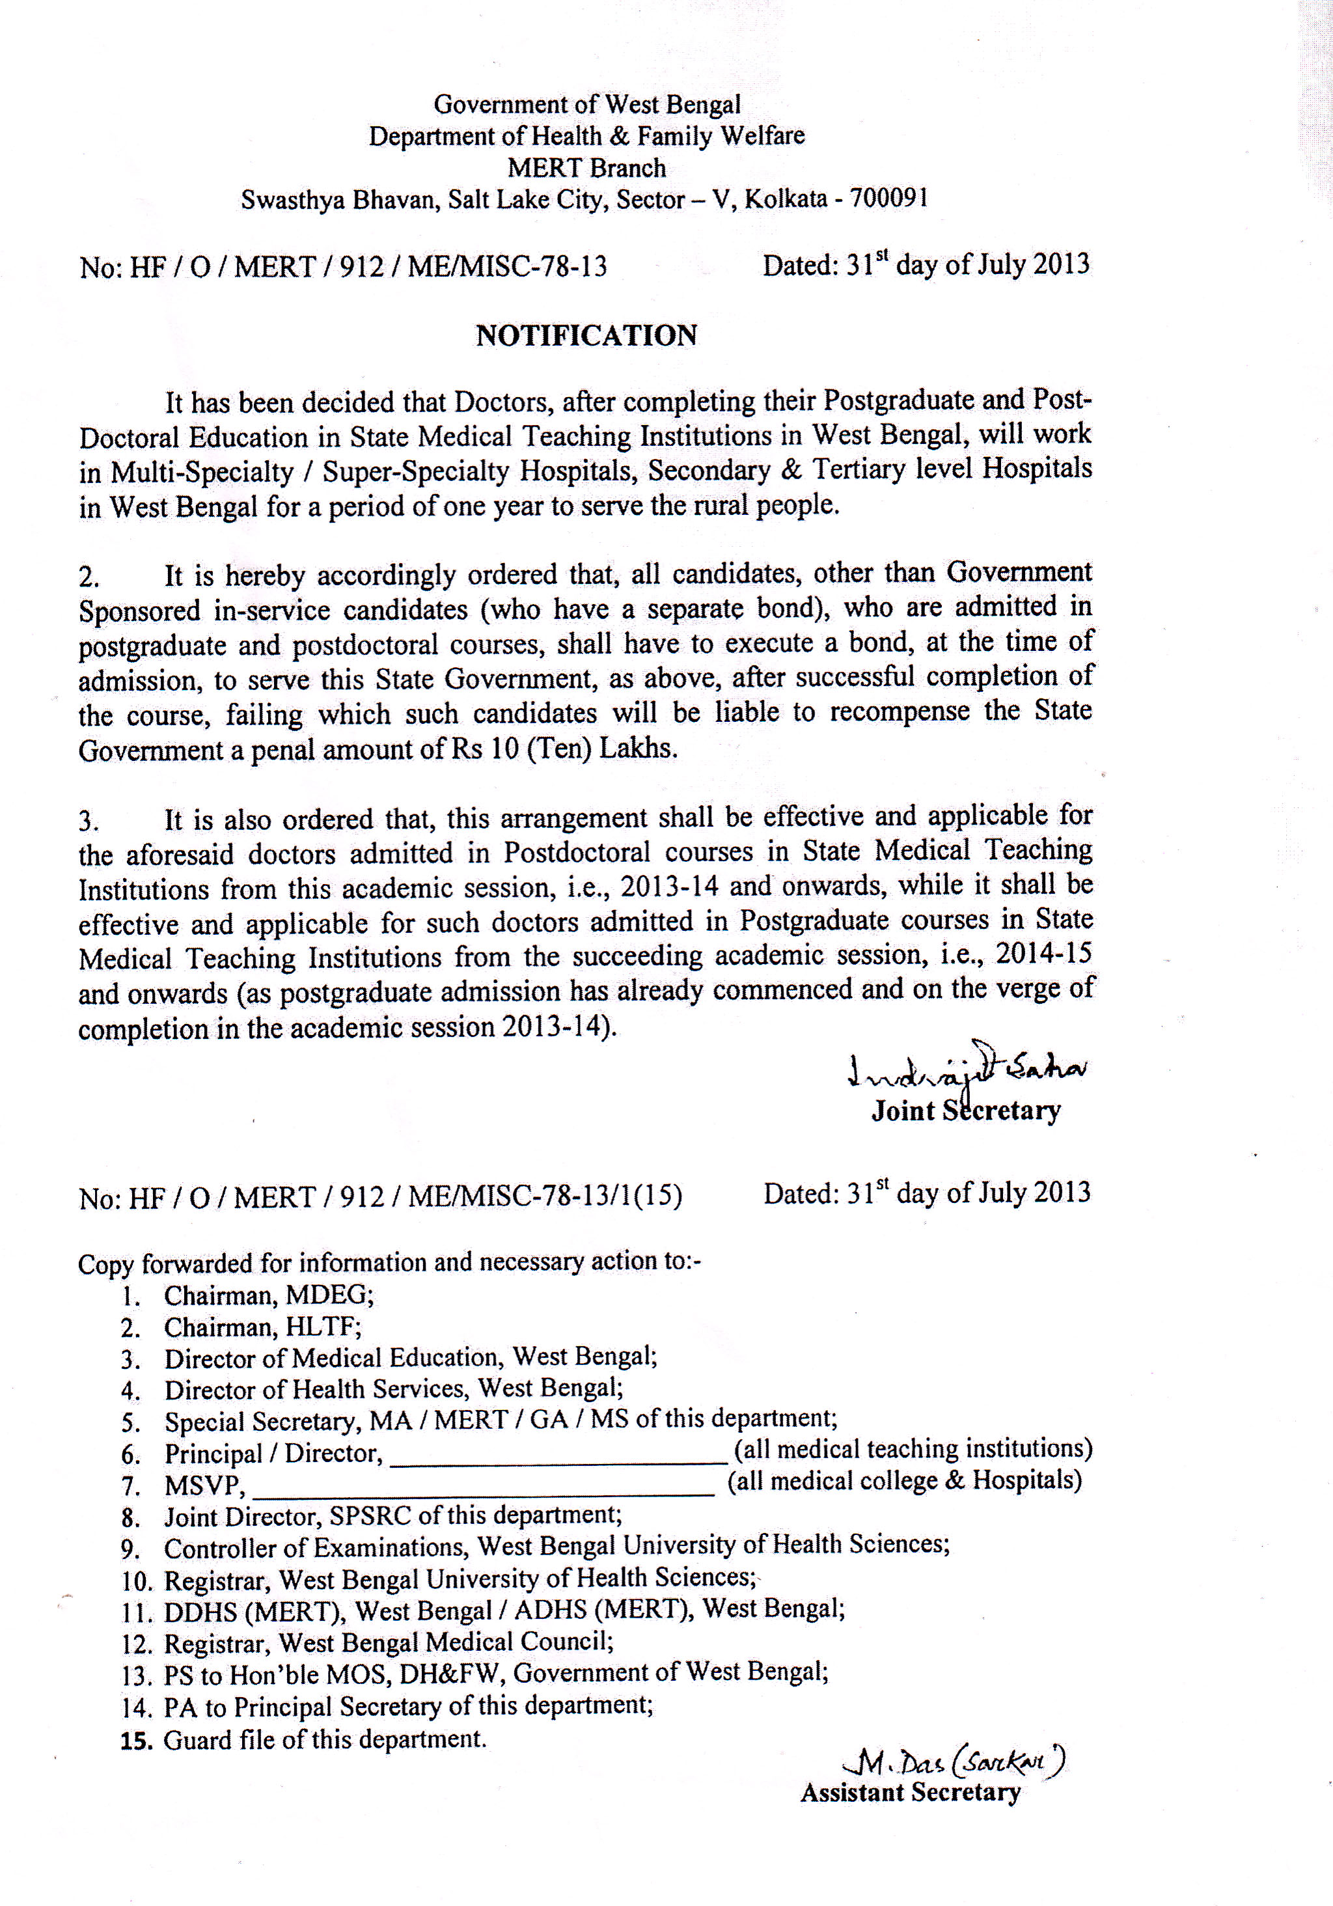
Appendix –VII

