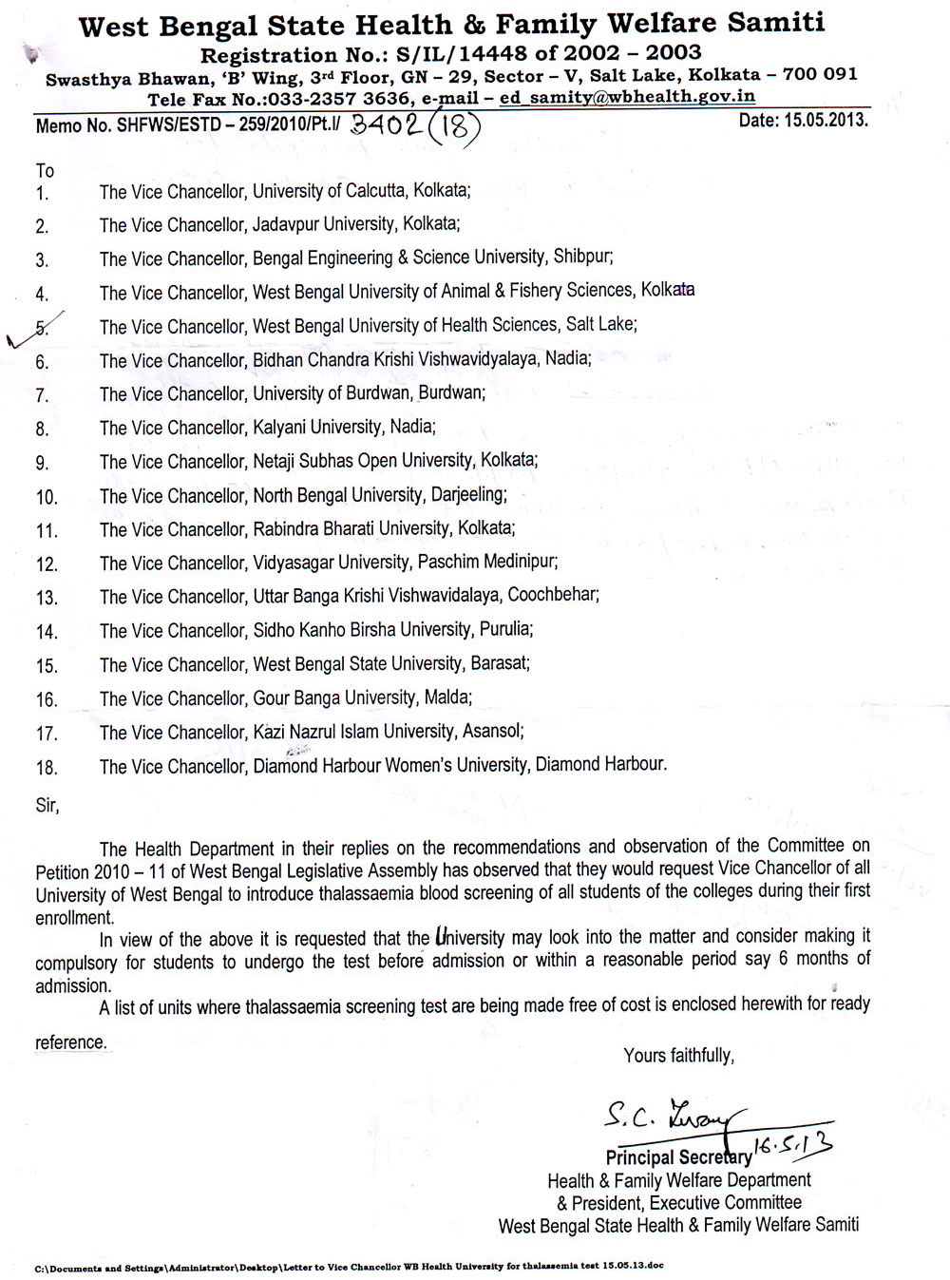


THE WEST BENGAL UNIVERSITY OF HEALTH SCIENCES
DD – 36, Sector – I, Salt Lake, Kolkata 700 064
Website: www.wbuhs.ac.in EPABX:2321-3461 / 2334-6602, Fax: 2358-0100

Memo No. OG/WBUHS/2013-14/434 Dated – 21.05.2013

N O T I F I C A T I O N

Attention of Principals of all colleges affiliated to the WBUHS is drawn to the fact that as per order of the Pr. Secretary, Health & Family Welfare Department and President, Executive Committee, West Bengal State Health & Family Welfare Samity, vide no. SHFWS/ESTD-259/2010 P.T.I./3402(18) dated 15.05.2013 that the Thalassaemia Blood screening of all students be made mandatory before/at the time of admission or within a reasonable period of six months from the date of admission.

By order
WBUHS

